**World Quant University**

**Professor: Ivan Blanco**

**Alpha Design I**

Nikolas Lippmann Pareschi - [nikolaslippmann@gmail.com](mailto:nikolaslippmann@gmail.com)

**Mini Project: Unit 3**

1. Download data for Dow Jones Index (DJIA) for the last 15 years.

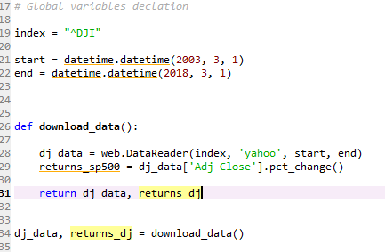

1. Compute daily percentage deviations of mid- price of DJIA from the 200 DAY Exponential Moving average (200DEMA) of close prices.

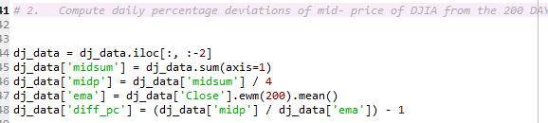

1. Prices above the 200-DEMA would get a positive value while those below would get a negative value

Code:

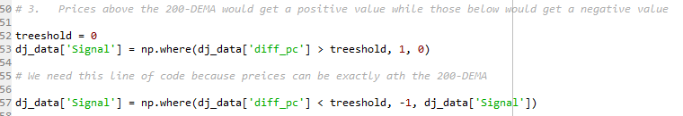

1. Whenever price is above 200-DEMA the market is generally considered to be in an up-move (and vice versa). Graphically represent the historical deviations and mark out clear periods of overall bullish and bearish regimes in DJIA.
2. For each of these regimes, clearly fit separate linear trend-lines and plot it on the same graph.

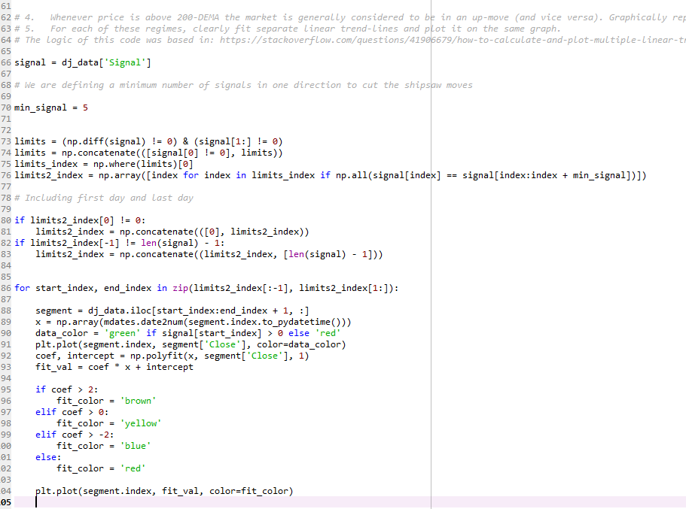

The prices are marked green in uptrends and red in downtrends. An uptrend is when the mean of open, high, low and closes are above the EMA of closes. The trend lines have the logic:

Coefficient > 2 --> brown

2 >= Coefficient > 0 --> yellow

0 >= Coefficient > -2 --> blue

Coefficient <= -2 --> red

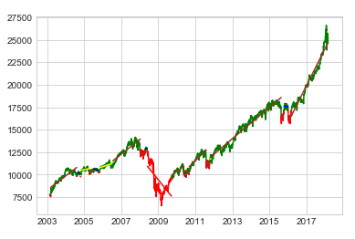

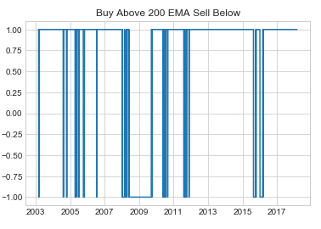

1. From the difference in relative slopes of the different trend lines, make a note about the relative shock during market regime shifts (e.g. – if a long bull market gave way to a sudden correction, the angle between the trend-lines of the two regimes would be high and would correspond to a violent regime-shift)

The slope is the derivative of price regarding to time, which is the coefficient of a linear equation. We can observe that very high slopes (above 2) tent to give room to very low slopes (below 2). Also, slopes between 0 and 2 tend to give room to slopes between -2 and 0. These observations are accordingly to a market phenomenon known as volatility clustering. High periods of volatility tend to be grouped in time and low periods of volatility tend to be grouped in time also.

1. Using the trend-line of the last-but-one regime, forecast the generic direction of price pattern for the last-regime. Did the projected and actual regimes match?

The pattern above is an indication. It didn’t work in the last trend, we had an acceleration from yellow to brown. If we have a decline it is more likely to be a red one, with slope below 2.